Dated 21 Apr, 2015

between

ST Electronics (Info-Software Systems) Pte Ltd.

and

**i2s Business Solutions Pte Ltd**

**BPM Platform setup for bulk tender T-1075**

**STATEMENT OF WORK**

**Parties**

1. **ST Electronics (Info-Software Systems) Pte Ltd**, a company having its registered at 1 Ang Mo Kio Electronics Park Road #04-01 Engineering Hub, Singapore 567710 (“**ST Electronics** ”);
2. **i2s Business Solutions Pte Ltd (**Company No.200412802C), a company incorporated in Singapore and having its registered address at 64 Cecil Street, Singapore 049711 (“**i2s**”).

This is a Statement of Work under, and forming part of, the Professional Services Agreement between the parties dated 21 Apr, 2015.

|  |  |
| --- | --- |
| For and on behalf  **ST Electronics (Info-Software Systems) Pte Ltd** | For and on behalf  **i2s Business Solutions Pte Ltd** |
| Signature : | Signature : |
| Name: | Name: |
| Title: | Title: |
|  |  |
| In the presence of  Signature:  Name:  Title: | In the presence of  Signature:  Name:  Title: |

# 1. SOW Term

# 1.1 SOW Commencement Date

The services described in the statement of work are to be commenced and effective from 22 Apr 2015

# 1.2. SOW Term

The SOW Term is the planned for Installation and configuration of IBM BPM on DEV, UAT and PROD platforms. The delivery approach is described in detail as set of defined Value Frames (refer Section 3.2 VF1).

At a high level, following are the key SOW Terms

* Installation of IBM BPM on DEV, UAT and PROD environment.
* Documentation of Installation by capturing the relevant screen shot during the installations (DEV, UAT and PROD) environments
* Provide the Knowledge transfer on the Installations (DEV, UAT and PROD) and configuration for Integration.
* Coordinate with IBM for any IBM BPM software application defects while performing installation.
* Production installation will follow the HA solution based on the architecture landscape.
* Acceptance testing will be based on the SAMPLE PROCESS/WORKFLOW test cases for functional testing and test cases for platform validation for ports, database and email connectivity for DEV, UAT and PROD environments.
* Provide the support during the Go Live.

# 1.3. Extension period(s)

N/A

# 2. Contract Representatives

**i2s’s Representative**

Harish Madhavan, Delivery Head

Email: harish@i2sbs.com

Phone: +65-65348514

**ST Electronics (Info-Software Systems) Representative**

Woo Weng Kong, Project Manager

Email: [woo.wengkong@stee.stengg.com](mailto:woo.wengkong@stee.stengg.com)

Phone: +65-9851 3942

# 3. Services

# 3.1. Project Objectives and Scope of Work

ST Electronics is embarking on a project to provide the IBM BPM installation on DEV, UAT and PROD environments and provide the training on BPM installation and configuration.

The following shall be the main objectives of this project.

* Check for the pre-requisites for the IBM BPM installation.
* Perform IBM BPM Installations for DEV, UAT and PROD environment.
* Hardening (Security related configurations) of the Platform.
* Verification will be done by executing test cases (SAMPLE PROCESS/WORKFLOW, Look & Feel and Integration touch points) covering functional and technical test cases.
* Commissioning of the IBM Business Process Manager.
* Screen shot based Installation documentation for successful installation of IBM BPM platform.
* Perform knowledge Transfer on the IBM BPM installation and configuration and it is capped for 2 consecutive working days.

# 3.2. Delivery Approach

Value Frames (“VF”) deliver value in small time-bound cycles. With a VF approach, it is clear what value you will receive for specific time/cost investments. Each VF articulates clearly the activities that will be executed and deliverables. The deliverables maps to the expectation provided in the factsheet.

This project will adopt a VF based approach. The project shall consist of the following VF:

VF1 –Understand the System Architecture and perform installation for IBM BPM platform setup

VF2- Knowledge Transfer

1. **VF1 – Understand the System Architecture and perform installation for IBM BPM platforms.**

In this activity, i2s will complete the requirements gathering on the infrastructure, perform the pre-requisites on the infrastructure and perform the installation of IBM BPM software for the DEV, UAT and PROD platform environments.

This will include:

1. Perform the pre-requisites on the infrastructure.
2. Perform the installation of IBM BPM software on DEV, UAT and PROD environments.
3. Preparation of screen shot based installation procedure documentation for DEV, UAT and PROD.

Verification will be done by executing test cases (SAMPLE PROCESS/WORKFLOW, Look & Feel and Integration touch points) covering functional and technical test cases.

1. Consider the High Availability Solution during the installation of PROD environment.
2. Delivery summary of completion report (Acceptance Testing report).

**i2s Responsibilities:**

i2s will perform Services which include the following tasks:

1. Check the pre-requisite on the infrastructure and provide the information about network firewall ports, credentials for remote access and Email server ports and credentials.
2. Verify and call out key dependencies and risks if any during the execution of the project.
3. Perform the IBM BPM installation on the DEV, UAT and PROD environments.

Verification will be done by executing test cases (SAMPLE PROCESS/WORKFLOW, L&F and Integration touch points) covering functional and technical test cases.

1. Based on the HA solution, Will perform IBM BPM installation and configuration in the production environment.
2. I2s will provide the project manager to manage the i2s resources.

**Customer Responsibilities:**

To facilitate timely and effective completion of this VF we require to commit to the following:

1. Provide a (SPOC) single point of contact to help i2s during the discussions, by setting up the required sessions.
2. Provide on the infrastructure and provide the information about network firewall ports, credentials for remote access and Email server ports and credentials.
3. Provide required inputs for Infrastructure on HA solution for production environment.
4. Share the installation planned timelines activities based on the overall baseline plan.
5. Coordinate with NUS stakeholders for confirmation and timely sign off.
6. Provide the project management to NUS.

**Deliverable Materials:**

The deliverables for this VF are:

* Installation document covering the step by step approach.
* Deliver the sample application.
* Deliver of test scenario and test cases.
* Deliver of acceptance summary report.

**Estimated Duration:**

The duration of this VF is expected to be 2 weeks.

**Completion Criteria:**

This VF is considered complete when the Installation Document and Verification of Sample Process/workflow and Acceptance Summary report.

1. **VF2 – Knowledge Transfer**

The purpose of this activity is to provide knowledge transfer on IBM BPM installation and configuration to **Customer**.

**i2s Responsibilities:**

i2s will perform Services which include the following tasks:

1. Configure development environment to support knowledge transfer needs.
2. Provide the knowledge transfer on IBM BPM installation and configuration.

**Customer Responsibilities:**

To facilitate timely and effective completion of this task we require **Customer** to commit to the following:

1. We assume the Knowledge transfer will be imparted to the resource, who has basic understanding of web applications and database.

**Deliverable Materials:**

N/A

**Estimated Duration:**

The activities above are time boxed for not more than 2 days.

**Completion Criteria:**

This VF is considered complete when the completion of Knowledge Transfer to **Customer**

# 3.3. Service Delivery Date

The service delivery will be managed by delivery dates according to the milestones for the project. The key milestones are as stated below.

|  |  |  |
| --- | --- | --- |
| **Milestone** | **Completion Timeline (in weeks)** | **Remarks** |
| **Environment Readiness** | Start Date + 10 days | 1. Go Live depends on the Acceptance from the NUS. |
| **Go Live** | Environment Readiness + 2 days |

# 3.4. Team Structure

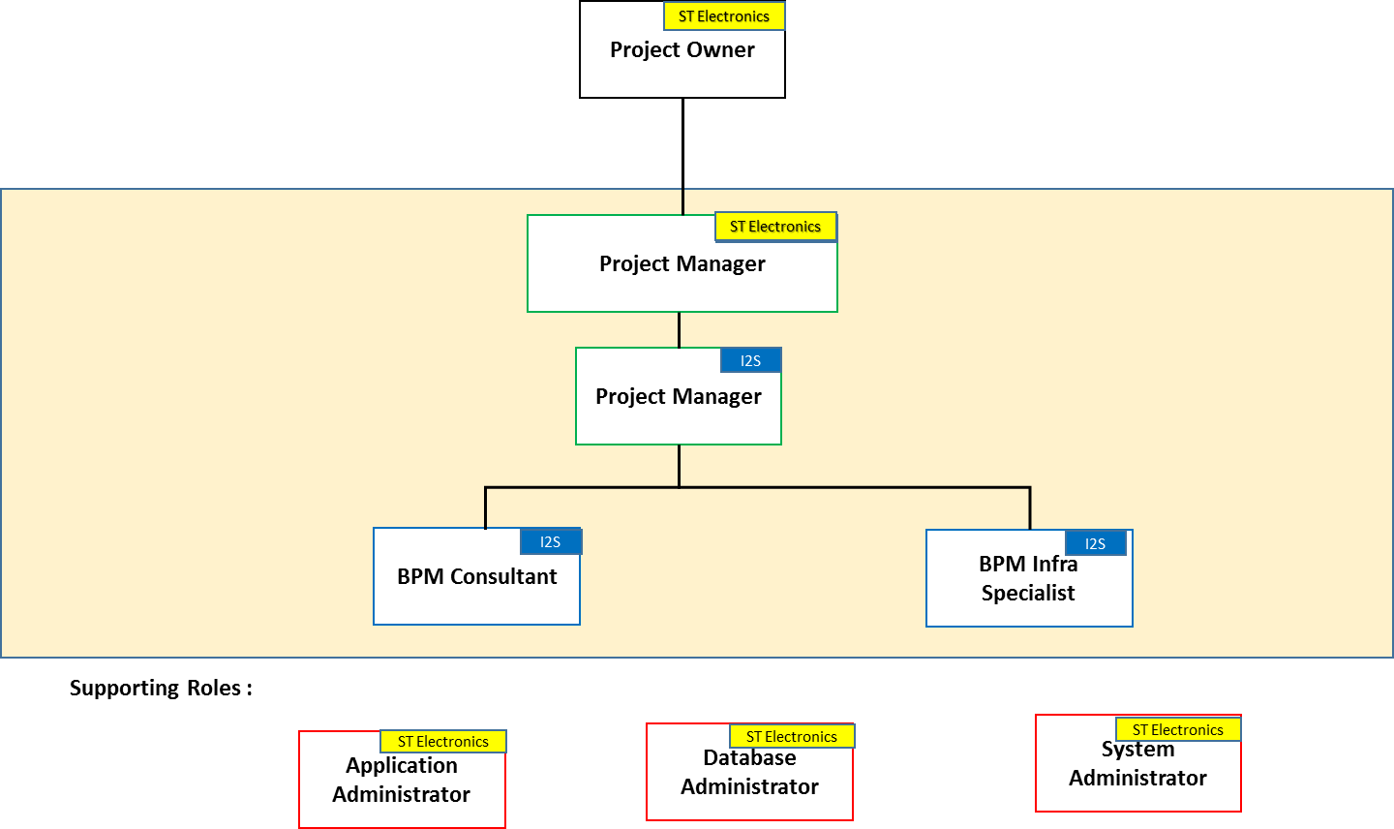

The supporting roles are illustrative and most of the customer responsibilities are outlined in the VF with greater clarity and detail.

* Application Owner – We need application owner details for each interfacing system and departments. This is to ensure they are informed and are accountable for the integration requirements.
* Application Administrator – i2s team will require access to the systems to perform testing.
* Database Administrator – This will involve providing access, creating scripts and performing day-day operational routine.
* System Administrator – This role involves providing logistics support to i2s team – Internet, Access to Floors, Conference Facility.

# 3.5. Assumptions and dependencies

* Functional SME Services will not be provided by i2s.
* PMO services will not be provided by i2s, by PMO we mean PM managing the customer for any SME and BA related roles.
* We assume a lead-time of 2 weeks is provided before we start the project. This will be used for resource mobilization.
* Customer team will chair all governance meetings with the customer and i2s will support/participate in the meetings.
* We assume, we will be provided with 3 environments: Development, UAT and Production.
* I2s will be provided access to test Active Directory, SAP, PEOPLE SOFT, Databases and Web services systems.
* We assume users are willing to spend time to test the system. Users here refer to a stakeholder who understands the system end-end both from technical and operational perspective.
* Resources to perform Test data refreshes from production to test boxes will be provided by the customer.
* Requests for server logins, accounts and access to servers need to be completed before starting of any project. Any delays in this will have an impact on project start date.
* The onsite resources from i2s will be given the adequate working infrastructure (for example, desks, desk phone and required software) for performing their activities.
* All the necessary sign offs will happen within 2 days of the artefact submission and completion of the milestone
* i2s shall be only performing installation on DEV,UAT and PROD and all relevant sizing of hardware and HA solution will not be i2s responsibility.
* Any activity mentioned in the "Scope Exclusion" will override the activities stated under "In Scope (Section (3.1, 3.2 and 3.5 )" section # 3.7

# Scope exclusion:

* Active directory creation of users and roles.
* SAP configuration and exposure of web services.
* Mobile enabling is out of scope.
* People soft integration and consume of API is out of scope.
* Real Analytics is not considered for Sample process/Workflow
* 2FA authentication out of scope.
* User Training not in scope.

# 3.6. Payment Terms (Services)

The below mentioned costs are not inclusive of GST.

|  |  |  |
| --- | --- | --- |
| **Milestone** | **Percentage** | **Amount in SGD** |
| Contract Sign Off | 15% | S$ 8250 |
| Installation (DEV,UAT and PROD) | 75% | S$ 41250 |
| Post Go Live Support Completion | 10% | S$ 5500 |